武汉大学本科生选课流程
- 登录武汉大学本科生教学管理系统（网址:http://210.42.121.241）；
Login to The Teaching Management System for Undergraduates of Wuhan University. （website：http://210.42.121.241）
- 输入学号、密码、验证码。原始密码为本人生日；本学期仍然延用上学期密码，如果密码不对或遗忘密码，请到学生所在学院更改密码。
Enter your student number, password and verification code. The original password is your birthday; This semester’s password is still extended to last semester's . If your password is incorrect or forgotten, please change the password at your own school.
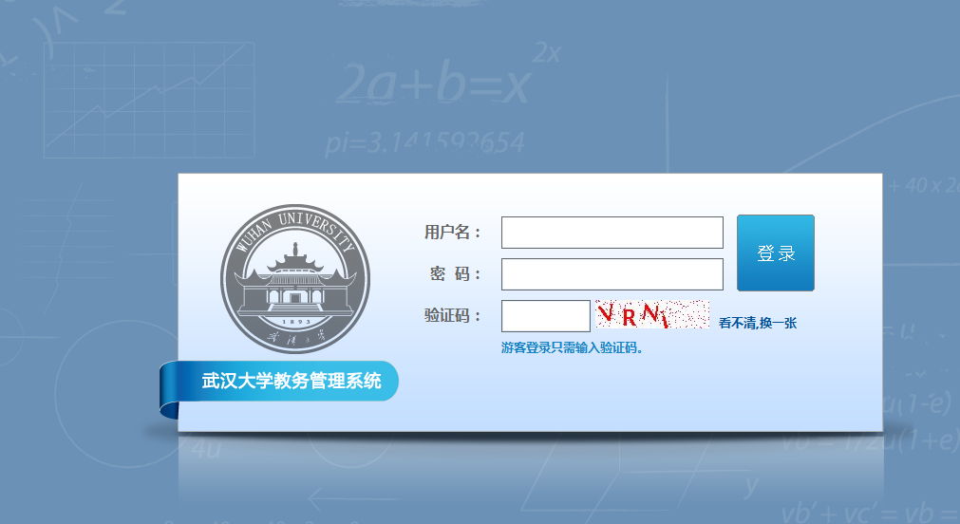
- 选择语言模式。在“公共选修”下面选择“简体中文”或“English”。
Choose language patterns. Choose “Simplified Chinese” or “English” under “Public Optional”.
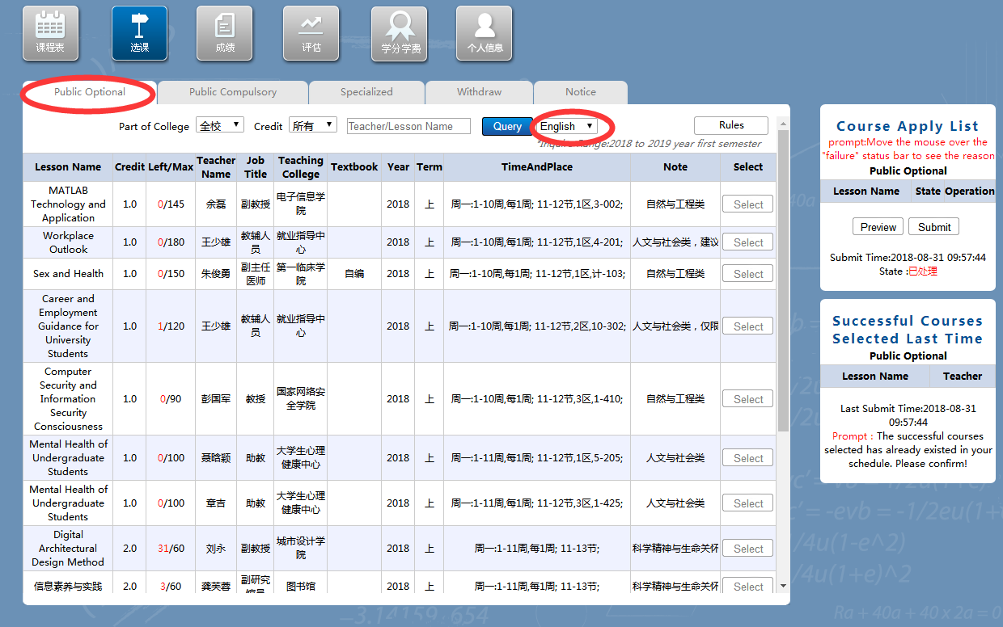

- 选择“选课”→“公共选修”，通识选修课所属领域可以通过“备注”属性查看→点击所选课程最后一列的“选课”按钮；如要取消该门课程的选课申请，在选课申请表中点击“删除”按钮→点击“提交”，提交成功后系统会有提示。
Choose "Course Selection" → "Public Optional". The field of general elective course can be viewed through the "Remarks" →Click the "Course Selection" button in the last column of the selected course; If you want to cancel the course selection application, please click the "Delete" button → Click the "Submit" button .When you submit the application successfully, there will be prompts.
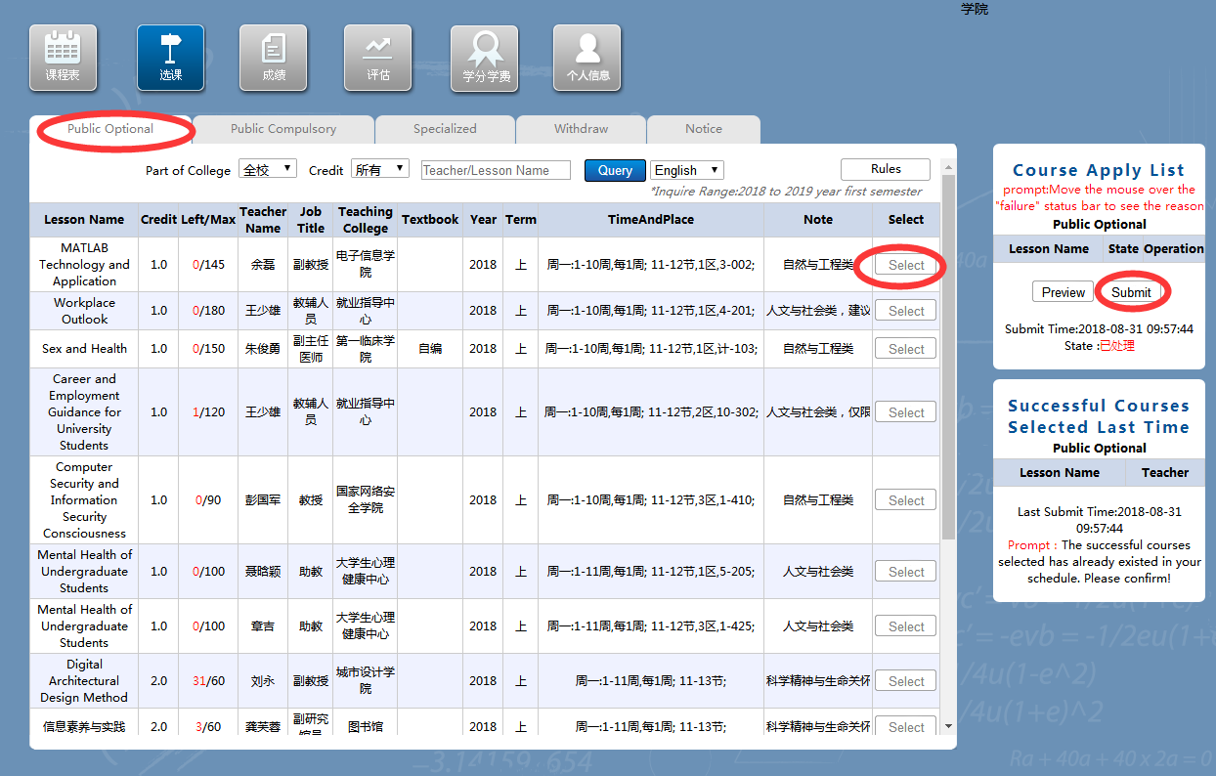

- 选择“选课”→“公共必修”，点击“大学英语” 或“体育”类课程→点击所选课头后面的“选课”按钮→点击右侧“选课申请单”下的“提交”，完成选课。
Choose "Course Selection" → "Public Compulsory".Click on "College English" or "Sports" courses → Click the "Course Selection" button behind the selected course head → Click the "Submission" button under the "Course Selection Application Form" on the right side of this page. You have completed the course selection.

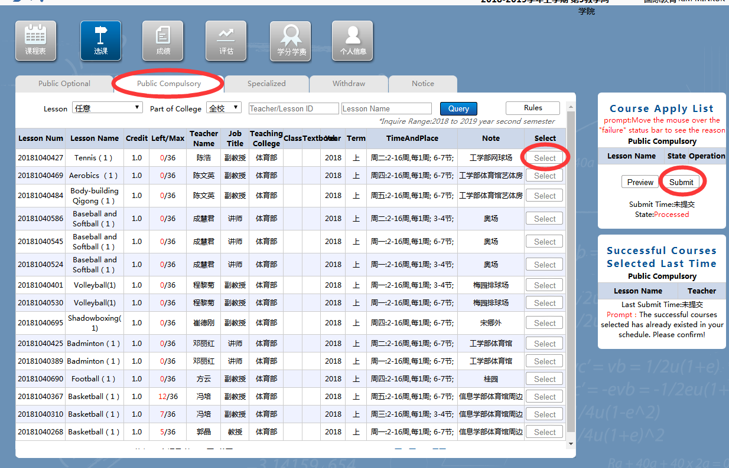

- 选择“选课”→“专业课”，按“学部-学院-专业-年级-课程名”，查找出本专业的计划课程→点击每门课后面的“选课”按钮→点击右侧“选课申请单”下的“提交”。
Choose "Course Selection"→"Professional Course" ,
According to the "School-College-Profession-Grade-
Course Name" order, find out the planned courses of this major → click the "Course Selection" button at the back of each course → click the "Submit" button under the "Select Course Application Form" on the right side of this page.
